Cupola
# Source: AI Source: Provided by: [Data Path: Persons Table -> ID Column: 1, Name_En Column: Motasem Essam] -> From: [ChatGPT] on [7/25/2026]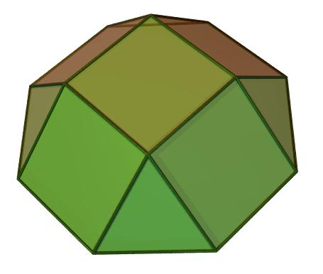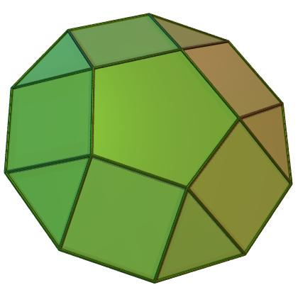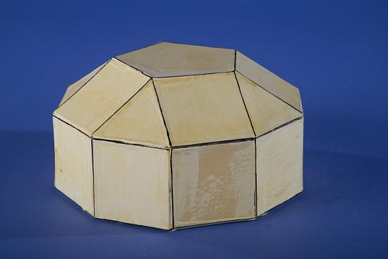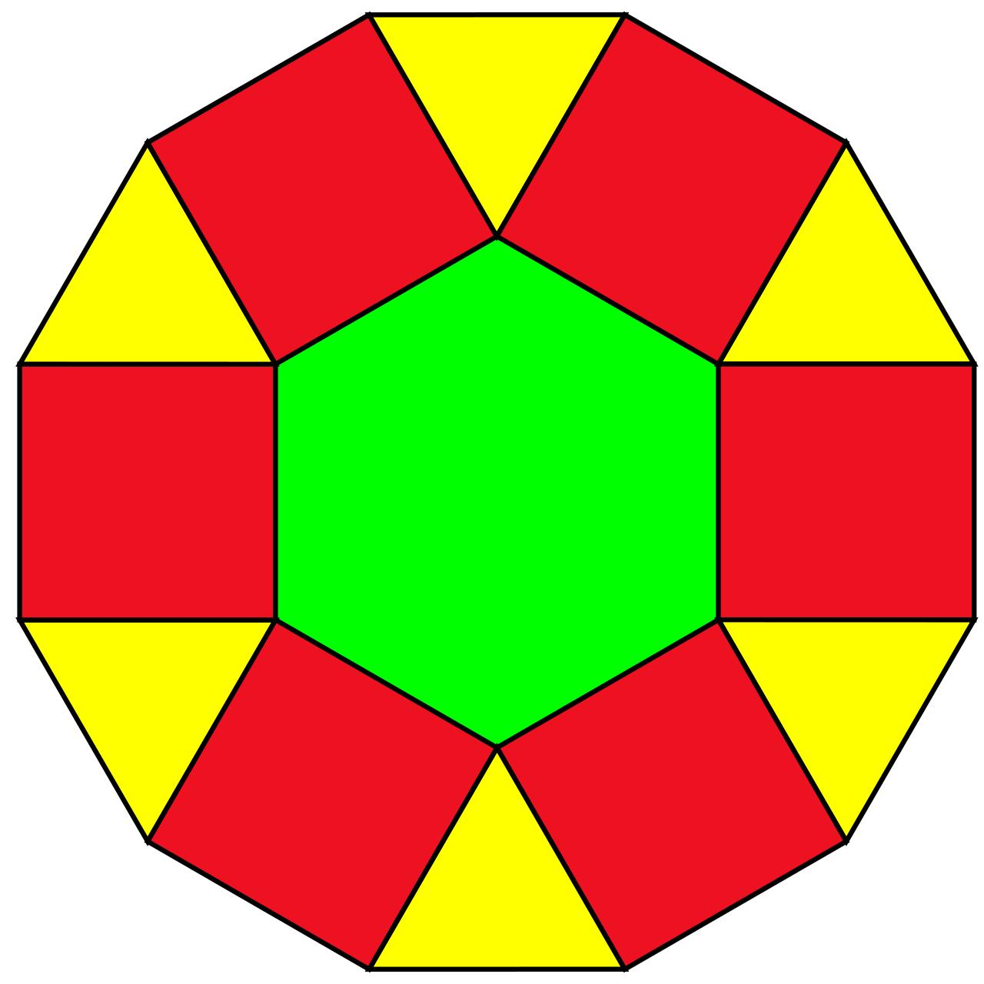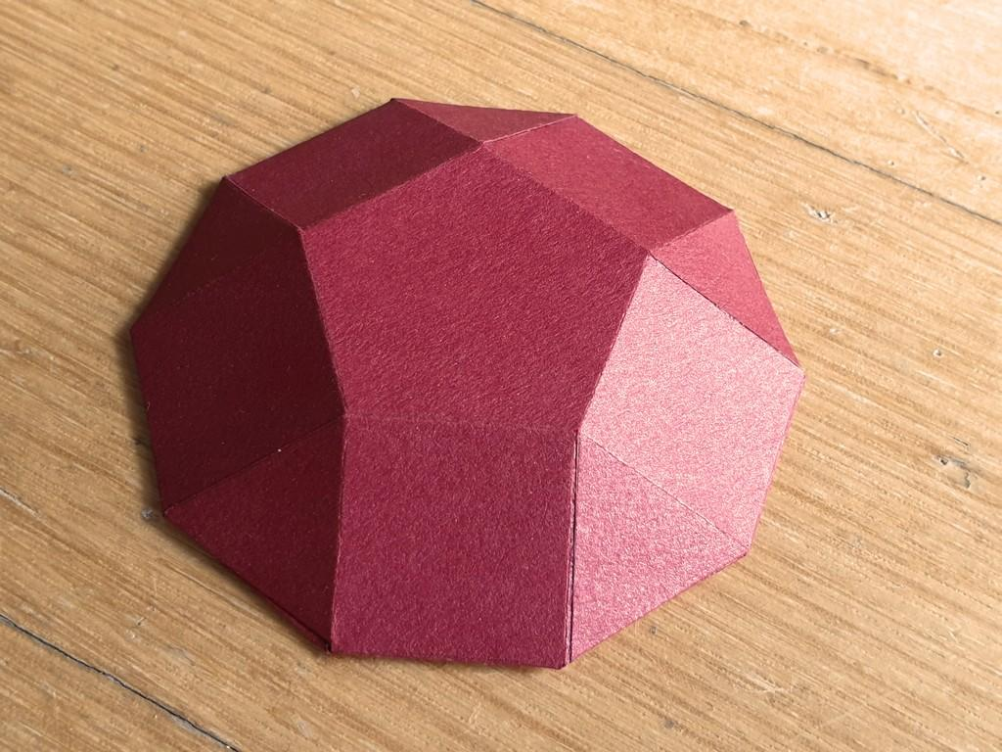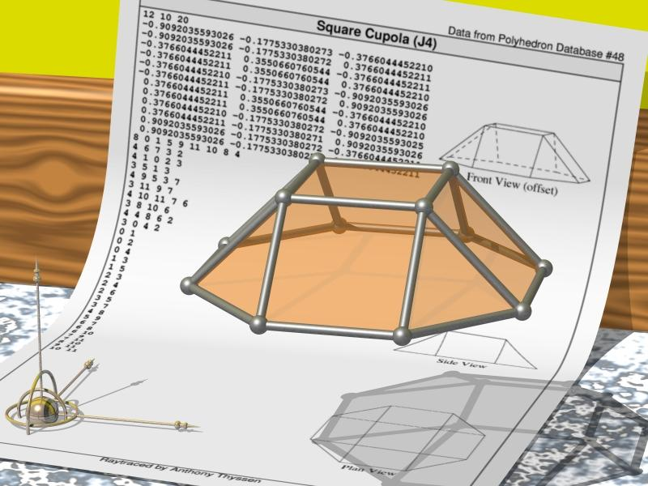

Definition
# Source: AI Source: Provided by: [Data Path: Persons Table -> ID Column: 1, Name_En Column: Motasem Essam] -> From: [ChatGPT] on [7/25/2026]
A Cupola is a polyhedron consisting of two parallel polygonal bases of different sizes, connected by a ring of alternating triangular and rectangular lateral faces.
The larger base is a regular $2n$-gon, while the smaller base is a regular $n$-gon. The lateral faces are arranged in an alternating pattern of triangles and squares (rectangles in the general geometric description).
A cupola is a type of prismatoid and is commonly classified as a Johnson solid when it has regular faces and satisfies the required convexity conditions.

Geometric Structure
# Source: AI Source: Provided by: [Data Path: Persons Table -> ID Column: 1, Name_En Column: Motasem Essam] -> From: [ChatGPT] on [7/25/2026]
A cupola consists of:
- Lower Base: A larger regular polygon with $2n$ sides.
- Upper Base: A smaller regular polygon with $n$ sides.
- Triangular Lateral Faces: $2n$ triangles connecting alternating vertices of the two bases.
- Square Lateral Faces: $n$ squares connecting the remaining vertices.
- Vertices: $3n$ vertices in total.
- Edges: $6n$ edges in total.

Face Composition
# Source: AI Source: Provided by: [Data Path: Persons Table -> ID Column: 1, Name_En Column: Motasem Essam] -> From: [ChatGPT] on [7/25/2026]
A cupola has four main face categories:
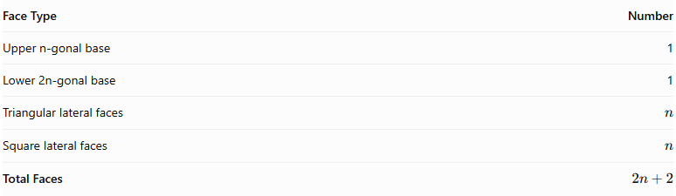
Face Type | Number
Upper n-gonal base | 1
Lower 2n-gonal base | 1
Triangular lateral faces | $$n$$
Square lateral faces | $$n$$
Total Faces | $$2n+2$$

Mathematical Properties
# Source: AI Source: Provided by: [Data Path: Persons Table -> ID Column: 1, Name_En Column: Motasem Essam] -> From: [ChatGPT] on [7/25/2026]
For an n-gonal cupola:
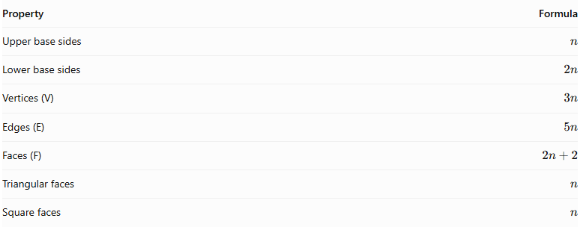
Property | Formula
Upper base sides | $$n$$
Lower base sides | $$2n$$
Vertices (V) | $$3n$$
Edges (E) | $$5n$$
Faces (F) | $$2n+2$$
Triangular faces | $$n$$
Square faces | $$n$$
Euler's formula:
$$V-E+F=2$$
Substituting the general formulas:
$$3n-5n+(2n+2)=2$$

Types of Cupolas
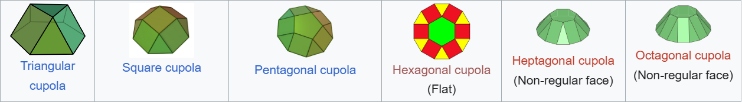

Square Cupola
# Source: AI Source: Provided by: [Data Path: Persons Table -> ID Column: 1, Name_En Column: Motasem Essam] -> From: [ChatGPT] on [7/25/2026]
- Upper base: Square
- Lower base: Octagon
- Triangular faces: 4
- Square faces: 4
- Vertices: 12

Pentagonal Cupola
# Source: AI Source: Provided by: [Data Path: Persons Table -> ID Column: 1, Name_En Column: Motasem Essam] -> From: [ChatGPT] on [7/25/2026]
- Upper base: Pentagon
- Lower base: Decagon
- Triangular faces: 5
- Square faces: 5
- Vertices: 15

Hexagonal Cupola
# Source: AI Source: Provided by: [Data Path: Persons Table -> ID Column: 1, Name_En Column: Motasem Essam] -> From: [ChatGPT] on [7/25/2026]
- Upper base: Hexagon
- Lower base: Dodecagon
- Triangular faces: 6
- Square faces: 6
- Vertices: 18
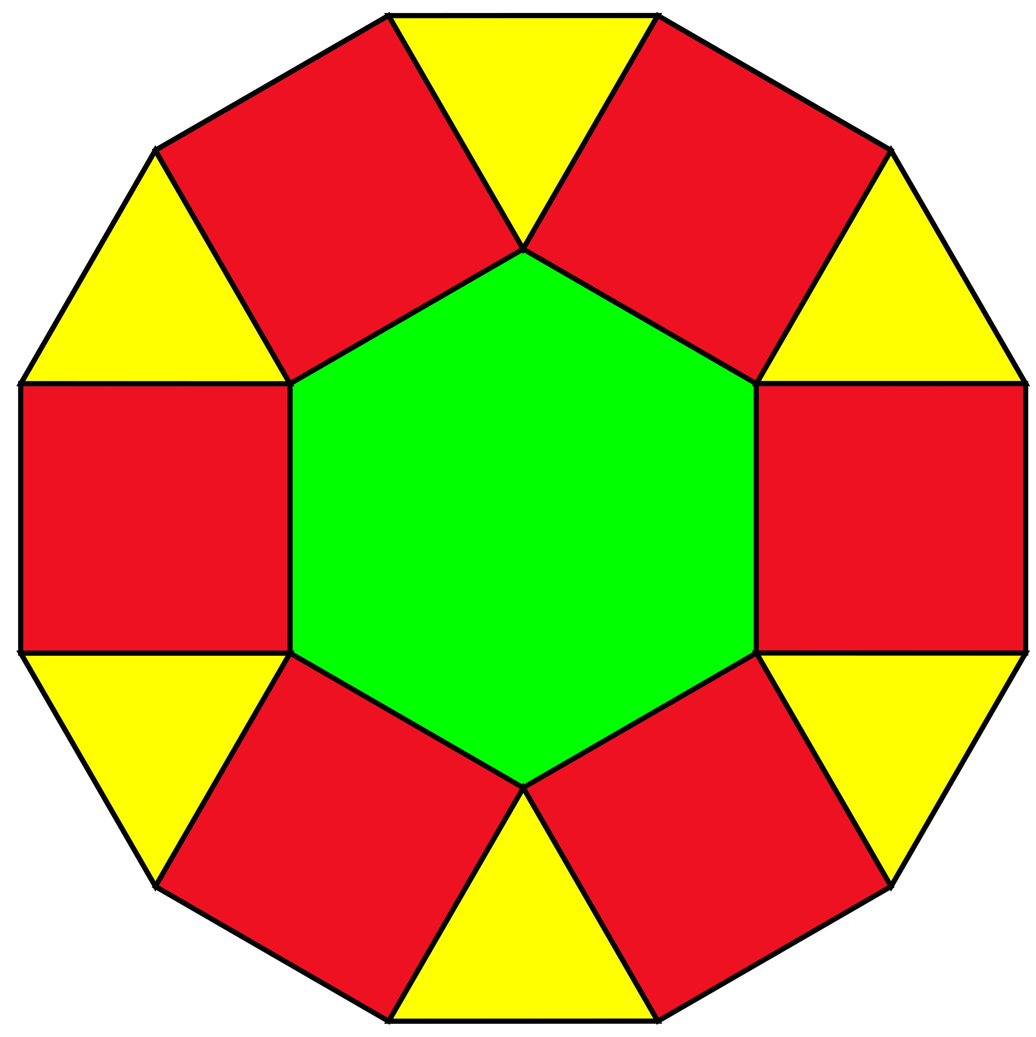

Constructing Cupola in Solid Geometry

Geometric Instruments Used
# Source: AI Source: Provided by: [Data Path: Persons Table -> ID Column: 1, Name_En Column: Motasem Essam] -> From: [ChatGPT] on [7/25/2026]
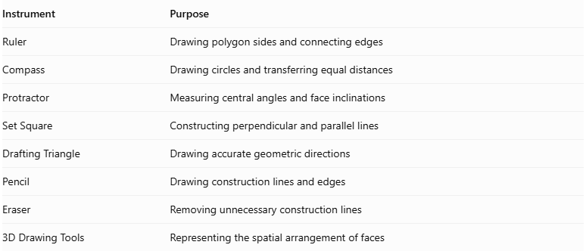
Instrument | Purpose
Ruler | Drawing polygon sides and connecting edges
Compass | Drawing circles and transferring equal distances
Protractor | Measuring central angles and face inclinations
Set Square | Constructing perpendicular and parallel lines
Drafting Triangle | Drawing accurate geometric directions
Pencil | Drawing construction lines and edges
Eraser | Removing unnecessary construction lines
3D Drawing Tools | Representing the spatial arrangement of faces

Instrument-Based Construction Procedures

Constructing a Standard Cupola
# Source: AI Source: Provided by: [Data Path: Persons Table -> ID Column: 1, Name_En Column: Motasem Essam] -> From: [ChatGPT] on [7/25/2026]
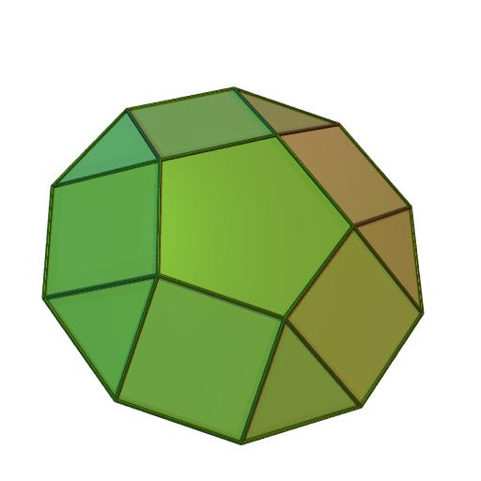
- Select the number of sides $n$ for the lower polygon.
- Draw the lower regular polygon using a ruler, compass, and protractor as appropriate.
- Determine the dimensions of the upper regular $2n$-sided polygon.
- Draw the upper polygon in a plane parallel to the lower base.
- Position the upper polygon so that its vertices alternate between positions corresponding to the lower polygon's vertices and side midpoints.
- Establish the vertical separation between the two bases.
- Connect the appropriate vertices of both polygons to form the triangular and square lateral faces.
- Check that the triangular and square faces alternate around the solid.
- Draw the visible and hidden edges.
- Erase unnecessary construction lines and finalize the three-dimensional representation.

Constructing an Elongated Cupola
# Source: AI Source: Provided by: [Data Path: Persons Table -> ID Column: 1, Name_En Column: Motasem Essam] -> From: [ChatGPT] on [7/25/2026]
- Construct the lower polygonal base.
- Construct a congruent parallel polygonal cross-section above it.
- Connect the corresponding vertices to form a prism.
- Construct the cupola above the prism.
- Connect the prism's upper boundary to the cupola's lower boundary.
- Complete the lateral faces and indicate visible and hidden edges.

Constructing a Gyroelongated Cupola
# Source: AI Source: Provided by: [Data Path: Persons Table -> ID Column: 1, Name_En Column: Motasem Essam] -> From: [ChatGPT] on [7/25/2026]
- Construct the lower polygonal base.
- Construct an antiprism above the lower base.
- Ensure that the upper boundary of the antiprism matches the lower boundary of the cupola.
- Construct the cupola above the antiprism.
- Connect the two structures along their common polygonal boundary.
- Complete the triangular, square, and antiprismatic lateral faces.
- Finalize the visible and hidden edges.
Construction note: These procedures use geometric instruments and geometric relationships. They are not coordinate-based construction methods. For polygon sizes that cannot be constructed exactly with a compass and straightedge alone, a protractor or another suitable geometric instrument can be used for the practical drawing.

Key Points
# Source: AI Source: Provided by: [Data Path: Persons Table -> ID Column: 1, Name_En Column: Motasem Essam] -> From: [ChatGPT] on [7/25/2026]
- It has two parallel polygonal bases with different numbers of sides.
- The larger base has twice as many sides as the smaller base.
- It has alternating triangular and square lateral faces.
- It has $3n$ vertices, $5n$ edges, and $2n+2$ faces.
- It is a type of prismatoid.
- Cupolas are used in the construction of other polyhedra, including certain elongated and augmented solids.

Classification
# Source: AI Source: Provided by: [Data Path: Persons Table -> ID Column: 1, Name_En Column: Motasem Essam] -> From: [ChatGPT] on [7/25/2026]
Solid Geometry
└── Types of Solids
└── Cupola
├── Square Cupola
├── Pentagonal Cupola
├── Hexagonal Cupola
└── n-gonal Cupola

Conclusion
# Source: AI Source: Provided by: [Data Path: Persons Table -> ID Column: 1, Name_En Column: Motasem Essam] -> From: [ChatGPT] on [7/25/2026]
A Cupola is a prismatoid with a smaller $n$-sided polygonal base, a larger $2n$-sided polygonal base, and $2n$ alternating lateral faces consisting of $n$ triangles and $n$ squares.

